Bio
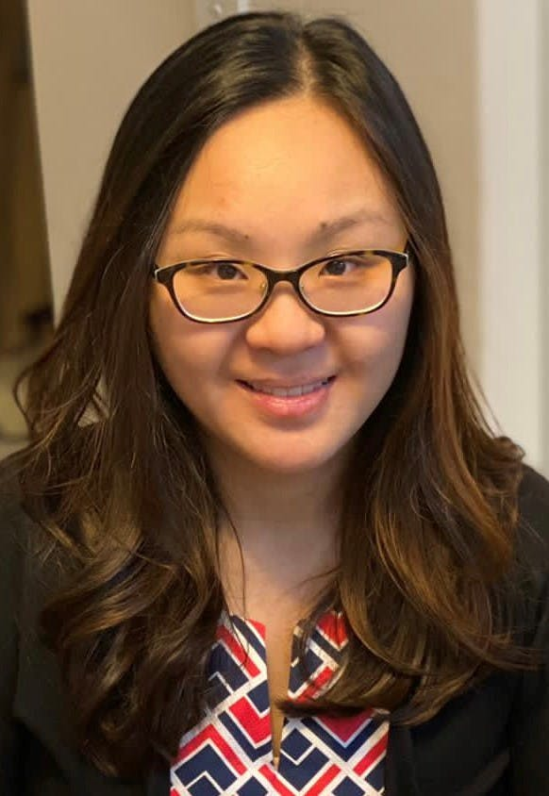

Overview
Dr Thio has returned to the Grange, having recently attained her Fellowship of the Royal Australian College of General Practitioners through a rigorous examination process. Dr Thio completed her Doctor of Medicine (MD) from the Universitas Indonesia, Indonesia, in 2011, and acquired her Australian Medical Council (AMC) certificate in 2013. She also holds a certificate in Childrens Medicine and is experienced in Mirena IUD and Implanon rod contraception. She has a holistic approach to health and believes that prevention and a healthy lifestyle are of paramount importance in maintaining health.

Areas of interest
- Implanon Insertion and Removal
- Mirena Insertion & Removal
- Pap Smear
- Women's Health

Qualifications and Experience

Languages spoken
- English
- Chinese
- Mandarin
- Indonesian

